Project Tracker

Iteration #2 Plan

10/13/2014 – 10/26/2014

# Revision History

|  |  |  |
| --- | --- | --- |
| **Author** | **Date** | **Description** |
| M. Rudner | 10/16/2014 | Initial Release |
|  |  |  |

# Objectives

The purpose of this iteration is to make our web application more aesthetically pleasing and add more functionality:

# Use Cases

The following use cases are involved in this iteration:

* UC001: Submit a project idea – The basic flow of this use case will be implemented.
* UC002: View a table of submitted project idea – The basic flow of this use case will be implemented.

# Task Schedule

|  |  |  |  |  |  |  |  |
| --- | --- | --- | --- | --- | --- | --- | --- |
| **Story ID** | Task | Effort | | Completion Date | | Owner | **Status** |
| **Est.** | **Actual** | **Est.** | **Actual** |
| S21 | Stream line navbar | 1 hour | 1 hour | 10/13 | 10/13 | Suenaga | Finished |
| S21 | Use larger text area element for Description input | 1 hour | 1 hour | 10/27 | 10/27 | Suenaga | Finished |
| S21 | Clean up home page | 1 hour | 1 hour | 10/27 | 10/27 | Suenaga | Finished |

# Task Pictures

## Showing a streamlined navbar:

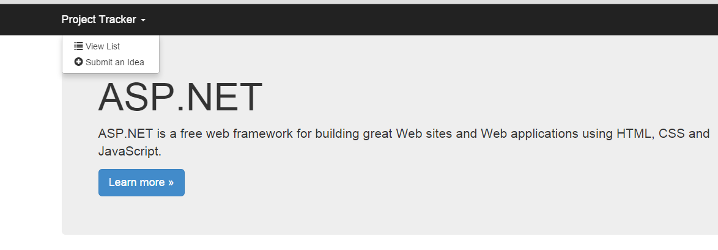

## Improved Homepage:

## 

## Larger Text area:

